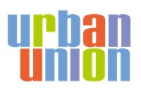

Urban Union

Consent Form

We would be grateful if you would complete this form to consent to the collection of the personal details and use of images and information provided for the My Sustainable Home competition.

By completing this form, you hereby grant Urban Union full rights to use the competition entry for publicity or other purposes to help achieve its aims.

You also acknowledge the visuals may be used in national and regional press, on social media, and in marketing material including newsletters and publications. This might include (but is not limited to), the right to use them in their printed and online publicity, case studies, newsletters and press releases. This consent will be valid indefinitely.

You understand that you have no interest in the copyright of, or moral rights to, the collateral produced. You also understand that consent can be withdrawn at any time in writing to Urban Union, Pavilion 1, 3 Robroyston Oval, Glasgow, G33 1AP.

Full Name
DOB
Parents name and telephone number
Parental Signature

